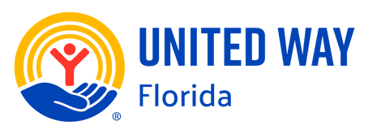
Florida United Ways Capitol Days 2026
February 3-5, 2026

AREA HOTELS:
HAMPTON INN & SUITES TALLAHASSEE CAPITOL - UNIVERSITY
824 Railroad Avenue, Tallahassee • (850) 692-7150

HOTEL DUVAL, AUTOGRAPH COLLECTION
415 N. Monroe Street, Tallahassee • (850) 224-6000

DOUBLETREE BY HILTON HOTEL TALLAHASSEE
101 S. Adams Street, Tallahassee • (850) 224-5000

RESIDENCE INN BY MARRIOTT TALLAHASSEE UNIVERSITIES AT THE CAPITOL
600 W. Gaines St, Tallahassee • (850) 329-9080

AC Hotel by Marriott Tallahassee universities at the capitol
801 S. Gadsden Street, Tallahassee • (850) 392-7700

HOTEL INDIGO TALLAHASSEE – COLLEGE TOWN, AN IHG HOTEL
826 West Gaines Street, Tallahassee • (877) 846-3446

Aloft Tallahassee Downtown
200 N Monroe St, Tallahassee • (850) 513-0313

HYATT HOUSE TALLAHASSEE CAPITOL - UNIVERSITY
1100 Railroad Avenue, Tallahassee • (850) 222-0039

Four Points by Sheraton Tallahassee Downtown
316 W Tennessee St, Tallahassee • (850) 422-0071

Source: Google

Each participant is responsible for making overnight reservations.
Hotel rooms are available on a first come, first served basis, so please make your reservations today!

